1. **DATA DICTONARY:**

**What Is Data Dictionary ?**

* A data dictionary contains metadata i.e data about the database.
* The users of the database normally don't interact with the data dictionary, it is only handled by the database administrators.
* The data dictionary is very important as it contains information such as what is in the database, who is allowed to access it, where is the database physically stored etc.
* The data dictionary generally contains the information about the following:
* Names of all the database tables and their schemas.
* Details about all the database, such as their owners, their security constraints, when they were created etc.
* Physical information about the table such as where they are stored and how.
* Table constraints such as primary key attributes and foreign key information etc.
* Information about the database views that are visible.
* The different type of data dictionary are as follows:
  + Active Data Dictionary :
    - If the structure of the database or its specifications change at any point of time, it should be reflected in the data dictionary. This is the responsibility of the database management system in which the data dictionary resides.
    - So, the data dictionary is automatically updated by the database management system when any changes are made in the database. This is known as an active data dictionary as it is self-updating.
  + Passive Data Dictionary :
* This is not as useful or easy to handle as an active data dictionary. A passive data dictionary is maintained separately to the database whose contents are stored in the dictionary.
* That means that if the database is modified the database dictionary is not automatically updated as in the case of Active Data Dictionary.
* **DATABASE DESIGN**

**D**ataBase **N**ame **:** ehealthcare

1. **Table Name :** admin

This Table Is Used To Store Information Of Admin.This Table Has Multiple Field Like admin_id,admin_email,admin_name and admin_password this all field are used to login in system for administration.

|  |  |  |  |  |  |
| --- | --- | --- | --- | --- | --- |
| Sr.no | Field Name | Data Type | Size | Constraint | Description |
| 1 | admin_id | Int | 3 | Primary Key,Auto Increment | Use to Store Admin Id |
| 2 | admin_email | Varchar | 25 | Unique , NotNull | Use to Store Email Id |
| 3 | admin_Name | Varchar | 15 | Notnull | Use to Store Admin Name |
| 4 | admin_password | Varchar | 8 | NotNull | Use to Store Password |

1. **Table Name :** doctor

This Table Is Used To Store Information Of Doctor .This Table Is Use When Any Patient Or doctor Want To See The Information Related TO Doctor On System Then This Table Is Use.

This Table Also Contain Image Field With That Doctor Can Upload His/her Image in Sysem.

|  |  |  |  |  |  |
| --- | --- | --- | --- | --- | --- |
| Sr.no | Field Name | Data Type | Size | Constraint | Description |
| 1 | doc_id | Int | 3 | Primary Key,Auto Increment | Use To Store Doctor Id |
| 2 | doc_email | Varchar | 25 | Unique , NotNull | Use to store doctor email |
| 3 | doc_name | Varchar | 15 | NotNull | Use To Store Doctor’s Name |
| 4 | doc_gender | Varchar | 6 | Notnull | Use to Store Gender Of Doctor. |
| 5 | doc_password | Varchar | 8 | NotNull | Use To Store Doctor’s  Email Password |
| 6 | doc_phoneno | Varchar | 12 | Unique , NotNull | Use To Store Doctor’s  Phone Number |
| 7 | spec_id | Int | 2 | References (specialist Table) | Use to Store Doctor’s Specialist |
| 8 | doc_charge | Int | 5 | NotNull | Use TO Store Charge Of Doctor |
| 9 | doc_img | Varchar | 30 | Notnull,unique key | Use To Store Path Of Image |

1. **Table Name :** schedule

This Table Is Use To Store Information Of Doctor’s Session Or Schedule . This Schedule Are Create By Doctor It Self And Also Editable And Also Admin Can manage It.

|  |  |  |  |  |  |
| --- | --- | --- | --- | --- | --- |
| Sr.no | Field Name | Data Type | Size | Constraint | Description |
| 1 | sche_id | Int | 3 | Primary Key,Auto Increment | Use To Store Schedule Id |
| 2 | doc_id | Int | 3 | References (doctor Table) | Use To Store Doctor Id |
| 3 | sche_title | Varchar | 20 | NotNull , unique key | Use To Store Schedule Title |
| 4 | sche_date | date |  | NotNull | Use To Store Schedule Date |
| 5 | sche_start | time |  | NotNull | Use To Store Schedule Starting Time |
| 6 | sche_end | time |  | NotNull | Use To Store Schedule Ending Time |
| 7 | sche_noappo | Int | 3 | NotNull | Use TO Store Maximum Appointment For Schedule |

1. **Table Name :** transaction

This Table Is Used TO Store Information of Transaction That Perform By Any Patient On Booking Appointment .This Table Have Multiple Reference Table For get Multiple Data Easyly.

|  |  |  |  |  |  |
| --- | --- | --- | --- | --- | --- |
| Sr.no | Field Name | Data Type | Size | Constraint | Description |
| 1 | tra_id | Int | 3 | Primary Key, Auto Increment | Use To Store Unique Id Of Transaction |
| 2 | doc_id | Int | 3 | References (doctor table) | Use To Store Doctor Id That reference From doctor Table |
| 3 | sche_id | Int | 3 | References (schedule table) | Use To Store schedule id That Reference From schedule Table |
| 4 | patient_id | Int | 3 | References (patient table) | Use To Store patient id That Reference From schedule Table |
| 5 | appo_id | Int | 3 | References (appointment table) | Use To Store Appointment Id That Reference From appointment Table |
| 6 | charge | Int | 5 | NotNull | Use To Store Charge Of Schedule / Session . |

1. **Table Name :** Specialist

This Table Is Use to Store Information Of All Specialist . This Table Is Used In Doctor table For Get Doctor’s Specialist.

|  |  |  |  |  |  |
| --- | --- | --- | --- | --- | --- |
| Sr.no | Field Name | Data Type | Size | Constraint | Description |
| 1 | spec_id | Int | 2 | Primary Key,Auto Increment | Use to Store Specialist Type Id |
| 2 | spec_type | Varchar | 25 | NotNull | Use to Store Specialist Type |

1. **Table Name :** article

This Table Is Use When Any Doctor Want’s TO Post His/her Article On any Health Topic Then This Table Is Used TO Store This Information . also It Contain Image Field With That Doctor Give Visual media.

|  |  |  |  |  |  |
| --- | --- | --- | --- | --- | --- |
| Sr.no | Field Name | Data Type | Size | Constraint | Description |
| 1 | article_id | Int | 3 | Primary Key,Auto Increment | Use to Store Article Unique Id |
| 2 | doc_id | Int | 3 | Reference(doctor Table) | Use to Store doctor Id That Reference From Doctor Table. |
| 3 | article_date | Date |  | Notnull | Use To Store Date of Article . |
| 4 | article_title | Varchar | 25 | Nonull | Use To Store Title Of Any Article. |
| 5 | article_description | Varchar | 500 | Notnull | Use To Store Deatil of Article. |
| 6 | article_image | Varchar | 25 | Notnull | Use To Store Path Of Image That Use In Article. |

1. **Data Flow Diagram :-**
   * **What Is DFD ?** 
     + A Data Flow Diagram(DFD) is a traditional way to visualize the information flows within a system. A neat and clear DFD can depict a good amount of the system requirements graphically.
     + It shows how information enters and leaves the system, what changes the information and where information is stored.
     + The purpose of DFD is to show the scope and boundaries of a system as a whole.
     + It may be used as a communications tool between a system analyst and any person who plays a part in the system that acts as the starting point for redesigning a system.
     + It usually begins with a context diagram as level 0 of the DFD diagram, a simple representation of the whole system.
     + To elaborate further from that, we drill down to a level 1 diagram with lower-level functions decomposed from the major functions of the system. This could continue to evolve to become a level 2 diagram when further analysis is required.
     + Progression to levels 3, 4 and so on is possible but anything beyond level 3 is not very common.
   * **Rule Of Creating DFD :** 
     + All Data Flows must flow to or from a process.
     + A process must have at least one input flow and one output flow.
     + The input to a process must be sufficient to produce output flows.
     + Process must transform data.
     + Data cannot flow between two entities.
     + Data cannot flow directly from an entity to data store.

**SYSTEM : E-Health Care Management System**

* + **admin Level-1 DFD :**

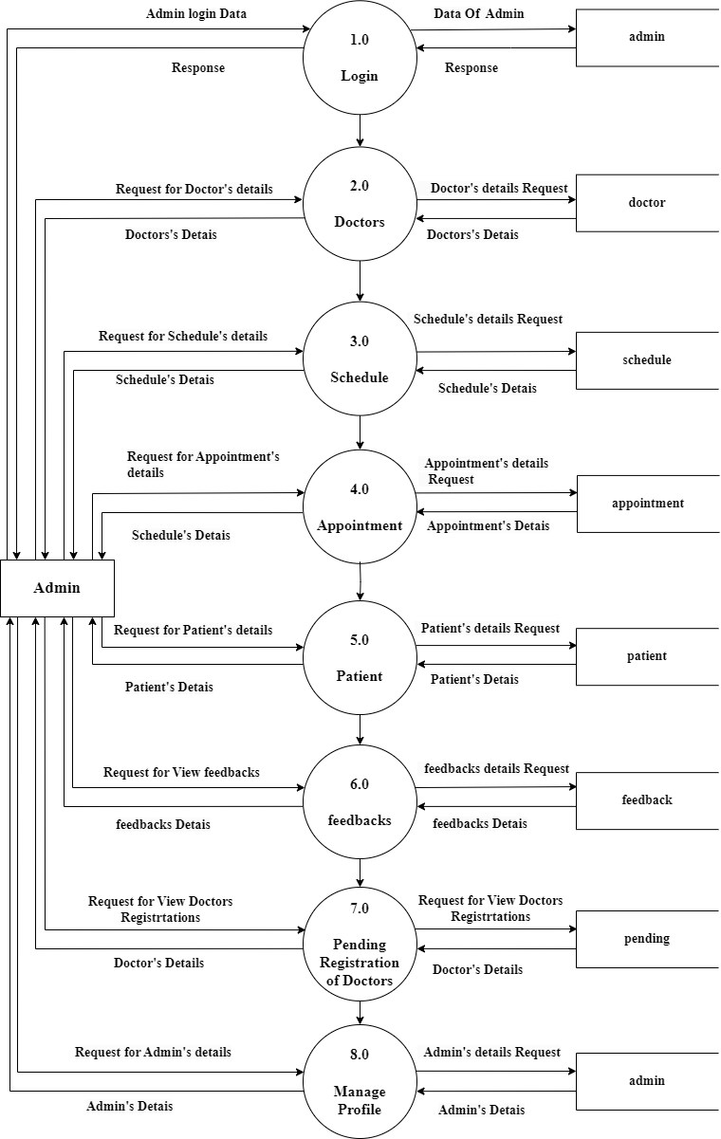

* + **Doctor Level – 1 DFD :**

